Technical Assignment: Synthetic Manuscript Generator

Role: Intern
Submission Deadline: 2 Days from Assignment Receipt
Target Quality Standard: ≥ 90% visual & structural parity with genuine historical folios

1. Assignment Overview
Your task is to build an automated, end-to-end Python Pipeline capable of synthesizing realistic historical manuscript folios along with fully synchronized ground-truth annotations. The output images will be evaluated against real scanned manuscript collections. The generated dataset must be sufficient to train modern Optical Character Recognition (OCR) models without domain adaptation failure.

2. Core Functional Requirements (Synthetic Manuscript Data Generation)
Develop a pipeline that generates synthetic Indic manuscript images from raw text, producing paired images and structured annotation files (.md).
- Manuscript Background Generation: Generate realistic manuscript backgrounds, including palm-leaf and aged handmade paper, with authentic textures, natural aging effects, and physical deformations such as page curling, folds, and surface warping.
- Text Rendering & Layout Generation: Render historically consistent manuscript text with natural calligraphic variations, traditional manuscript layouts, multiple text blocks, marginal annotations, and section or punctuation markers also add highlighted text in the manuscript and side text.

3. Submission Deliverables
- Source Code: Complete, modular Python implementation hosted in a GitHub repository, including setup instructions and configurable parameters .
- Synthetic Dataset: Generated manuscript images along with their corresponding Markdown (.md) annotation files, hosted in a public Hugging Face Dataset repository.
- Documentation: A README.md describing the project overview, installation, usage instructions, repository structure, and dataset organization also add hugging face dataset name.

4. Submission Instructions
- Push your code to a private GitHub/ Huggingface repository and grant access to the hiring team.
- Include a script generate.py that can be run via terminal command:
python generate.py

5. Constraints
- Manuscripts should appear as realistic as possible and closely resemble authentic historical manuscripts.
- Text must remain within the manuscript boundaries, with no horizontal or vertical overflow.
- Support natural color variations in the rendered text and ink.
- Generate diverse manuscript backgrounds with variations in texture, aging, and material.
- Support natural handwriting characteristics, including slight slant, waviness, and irregular text alignment.
- Incorporate realistic manuscript artifacts such as ink smudges, ink bleeding, faded strokes, and other natural imperfections.
- The rendered text should closely resemble handwritten manuscript calligraphy rather than digitally typeset text.
- The pipeline must support three Indic scripts (and should be changeable for any other script): Devanagari, Modi, and Sharada.
- Generate 100 images per script, split into 85% training (85 images), 10% validation (10 images), and 5% testing (5 images).
- Upload the dataset to Hugging Face with three subsets: devanagari, modi, and sharada.
- Each subset must contain the train, validation, and test splits following the specified distribution.

Sample :

Image_1.png
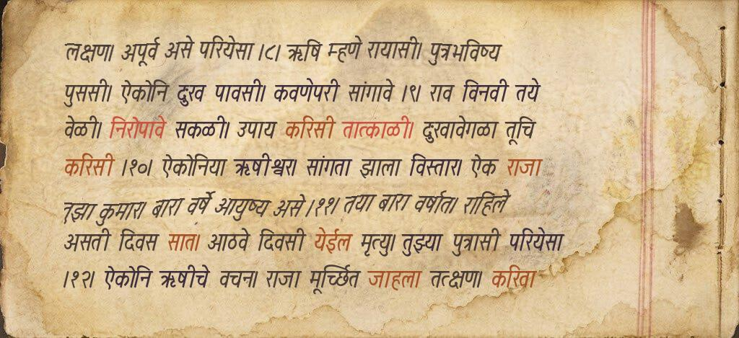

Image_1.md

लक्षण। अपूर्व असे परियेसा ।८। ऋषि म्हणे रायासी। पुत्रभविष्य
पुससी। ऐकोनि दुःख पावसी। कवणेपरी सांगावे ।९। राव विनवी तये
वेळी। निरोपावे सकळी। उपाय करिसी तात्काळी। दुःखावेगळा तूचि
करिसी ।१०। ऐकोनिया ऋषीश्वर। सांगता झाला विस्तार। ऐक राजा
तुझा कुमार। बारा वर्षे आयुष्य असे ।११। तया बारा वर्षात। राहिले
असती दिवस सात। आठवे दिवसी येईल मृत्यु। तुझ्या पुत्रासी परियेसा
।१२। ऐकोनि ऋषीचे वचन। राजा मूर्च्छित जाहला तत्क्षण। करिता

